Vertex Swarm Challenge 2026 — Full Breakdown
Make machines talk directly to machines — no cloud, no central server, no middleman. (peer to peer)

Old Way | Vertex Way
Cloud server coordinates everything | Machines coordinate with each other directly
One server fails → whole fleet stops | One node fails → swarm self-heals
Vendor-locked (only same-brand devices) | Any brand, any device, same swarm
High latency (cloud round-trips) | Ultra-low latency (local mesh)

Track 2: Search & Rescue Swarms

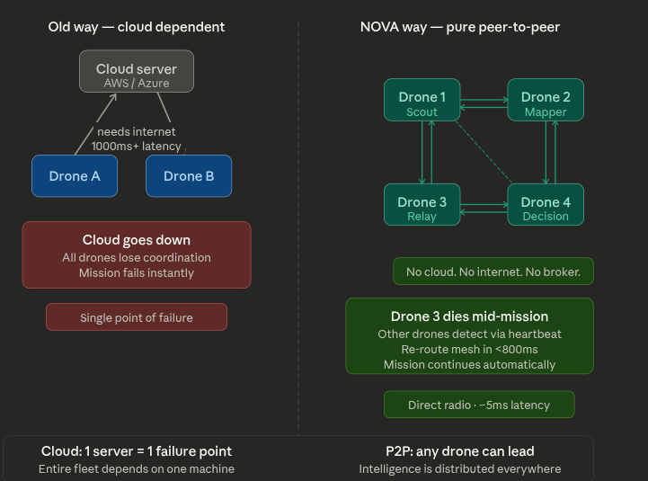

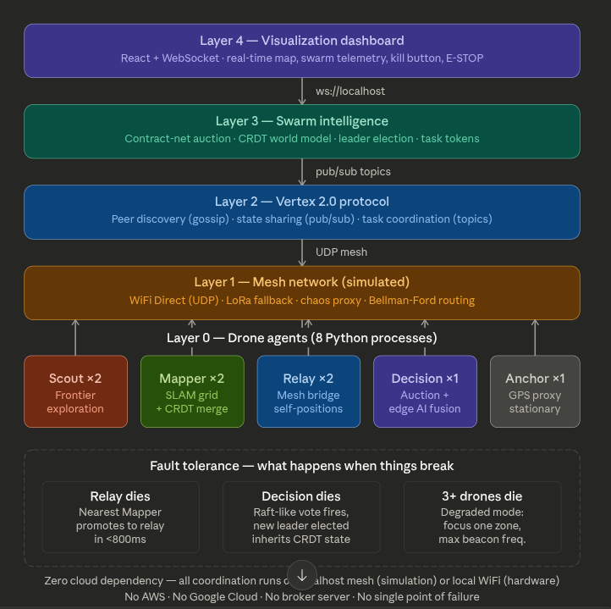

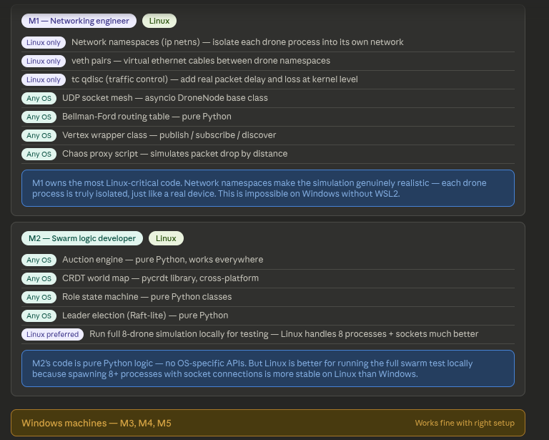
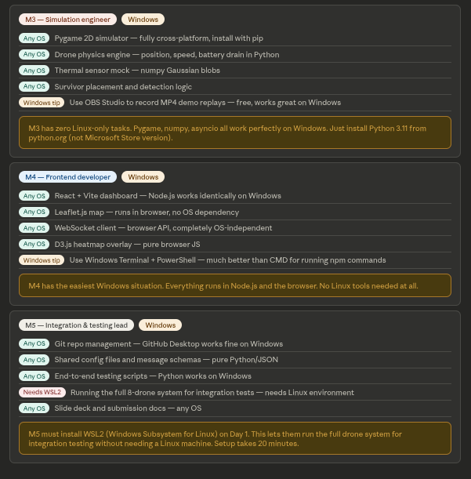

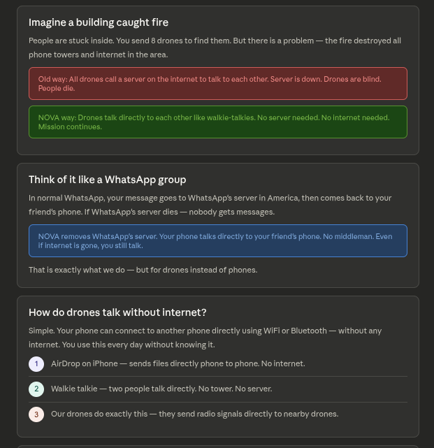
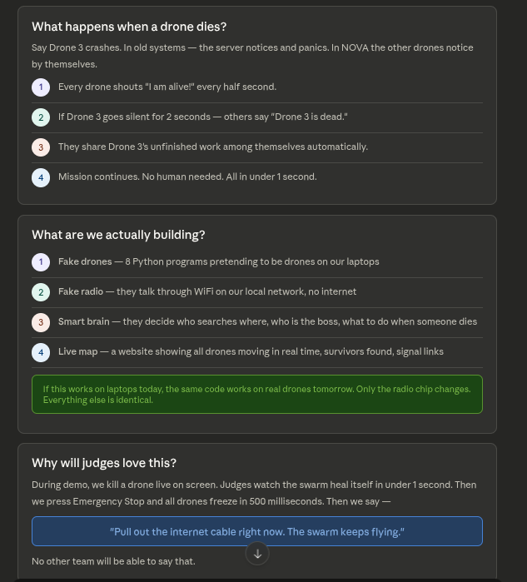
Why Nova is Good?
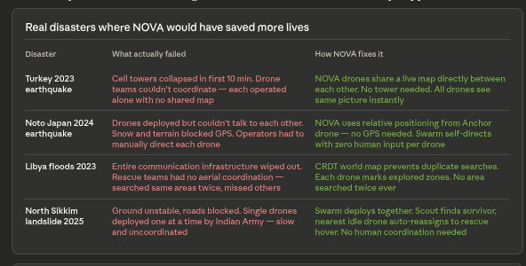
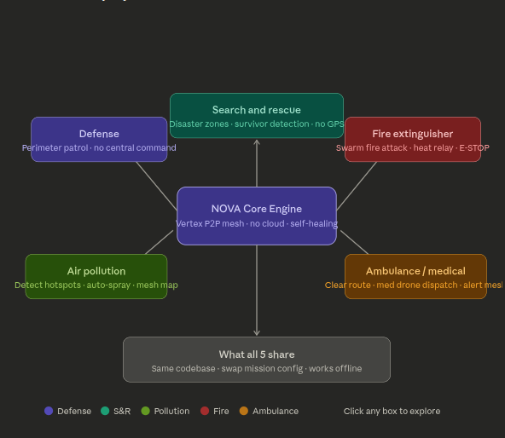
"We built one engine. We showed it in a disaster zone today. Tomorrow it defends a border. The day after it cleans Delhi's air. The code doesn't change — only the mission does."

